**Product: CrossTOX®**

**Homogenise sample in order to achieve optimal extraction efficiency.**

**1 Sample homogenization**

* Homogenise a sufficient amount of sample material by milling to obtain high surface accessibility for optimal extraction.

**2.1 Extraction procedure**

* Extract 20 g of homogenized sample with 100 mL (84 % acetonitrile / 16 % water) in a blender jar at high speed for five minutes. The column performance is not effected by acidification with 1% acetic acid, which improves extraction efficiency for fumonisins, so an alternative extraction solvent (84 % acetonitrile / 15 % water / 1 % acetic acid) could be used.  
  For alternative extraction tools, evaluate the extraction times.
* Blender jar / Ultra-Turrax (5 minutes)
* Magnetic stirrer at high speed (10 minutes)
* Orbital shaker (60 - 90 minutes)

**2.2 Extraction procedure for aflatoxins and ochratoxin A from paprika and chili samples**

* Extract 10 g of homogenized sample with 100 mL (84 % acetonitrile / 15 % water / 1% acetic acid) and 50 mL n-hexane for defatting in a blender jar at high speed for at least 10 minutes. For alternative extraction tools, evaluate the extraction times.

After extraction, remove any turbidity and insoluble matrix material or let it settle. Optional pass the extract through a plaited filter or centrifuge at 3000 x g for 5 Minutes, which support phase separation. No residues of n-hexane should be applied onto the CrossTOX column

**3.1 Clean-up procedure for cereals, nuts and dried fruits**

* Pass a maximum of 3 mL (represents 0.6 g matrix equivalents) through the CrossTOX® column. Collect the flow through and dispense it in HPLC vials for mycotoxin analysis.

**3.2 Clean-up procedure for paprika and chili samples**

* 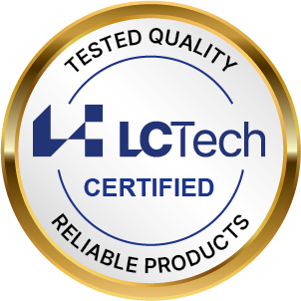Pass a maximum of 0.5 mL (represents 0.05 g matrix equivalents) through the CrossTOX® column at low flow rate. Collect the flow through and dispense it in HPLC vials with insert for mycotoxin analysis.The sample is passed through a plaited filter to remove precipitations.

**If you have any questions, please contact:** mycotoxins@LCTech.de